**Big-Data Content Retrieval, Storage, and Analysis**

**(Crisis in Ukraine)**

By: Amit Kamat

University at Buffalo

**1. Abstract**

The Big-Data Content Retrieval, Storage, and Analysis project gives one a fantastic exposure to data wrangling, map-reduce, and web-enabled data visualization. Through the use of various tools we select a trending topic, in this case the crisis in Ukraine, and collect relevant data that we subsequently explore.

I plan on implementing this project in three parts. First and foremost I need a data wrangling technique for which I will use python, Tweepy, and the Twitter API. I will refactor the data into a predefined format and make sure to leave only relevant information within, removing stop words, links, and other unnecessary parts. I will then proceed onto the map reduce portion of the project where I shall implement the word count, co-occurrence, k-means, and shortest path algorithms for the data. I plan on using the in-mapper combiner technique wherever possible. Both pairs and stripes approach, including relative frequency, will be implemented for the co-occurrence. For the shortest path problem I plan to use replies, retweets, and mentions, basically anything starting with a ‘@’ in a tweet, as the connection between nodes. Last but not least I will implement the visualizations using Gephi coupled with Sigmajs Exporter.

As a creative venture I plan on collecting origin coordinates for tweets while utilizing Tweepy and the Twitter API. I will use those to create a nice plot on the world map. I personally think it will be an interesting thing to see.

**2. Project Objectives**

The Big-Data Content Retrieval, Storage, and Analysis project, at the very least, will meet the following list of objectives:

* Learn about data wrangling by utilizing the Twitter API.
* Learn more about big data collection and analysis.
* Learn to use Hadoop and map-reduce.
* Learn more about distributed file systems such as HDFS.
* Explore different techniques and algorithms relevant to map-reduce.
* Explore different techniques in web-enabled data visualization.
* Provide useful metrics and visualizations.

**3. Project Approach**

First and foremost I plan on reading (and re-reading) Chapters 3 and 4 of *Data-Intensive Text Processing with MapReduce* until I feel comfortable with the algorithms presented there. Once I am ready to proceed I will commence with deciding on a data wrangling technique. I am thinking of using Tweepy because I have had it as a goal to get better at Python. I plan on cleaning up the data by removing stop words, links and other unneeded elements. I also plan on delimiting the data in such a manner so that different elements can be easily distinguished and retrieved. I will have python scripts intended to combine/split the collected data appropriately. I will definitely collect more than 200000 tweets (363000 to be exact).

Once I am done with the wrangling, I will set up hadoop and start along. I plan of doing as much as possible directly using hadoop map-reduce in order to get good at it. This is why I will do the word count problem using an in-mapper combiner. This is also, why I plans to use secondary sort in Hadoop when it is generally perfectly fine to do the sort for most trending words using other methods.

The co-occurrence problem has two parts, pairs and stripes. Both will have in-mapper combiners. I will write my own Writable Comparable for the pairs, which should be interesting. I will also have a petitioner. For both the algorithms, I will follow the methodology described in the book as closely as possible. Just for fun I will have a sorted by count map reduce function in place.

For K-means, I will read the post provided in the project description. Once I understand it I shall commence. I plan to use counters for this algorithm to pass along data between iterations. Once the centroids are found, I will create files listing users, their followers, and respective groups. For more visualizations, I will run word count and co-occurrence for each group separately as well.

Finally yet importantly in terms of algorithms I will write out the shortest path. I plan to follow what is described in the book as closely as possible. I will use my most followed user as the start of the graph. I will initialize the graph itself by finding points that are somewhat midpoints in the set of follower counts. I will then run the regular algorithm, which should provide me with a nice labeled graph.

For visualizations, I will use Gephi and sigma.js. Since the data set is very large, it will be very nice to look at it through a web-enabled visualization. Using Python I will create scripts, which reformat the regular outputs into graph files for Gephi. I will then export those graphs using Sigmajs Exporter.

**4. Data Format and Source**

The data source is through the twitter API, which is set to stream tweets containing information related to Ukraine, Russia, and the ongoing crisis there. I am specifically using Tweepy to collect the data. I will refactor the data in such a manner as to leave only relevant information, removing stop words, links, and other irrelevant details. I have provided a README.txt in the /data/ folder where you can find more information about the format and source. Here is a copy for your reference:

================================================================================

This folder contains the following:

================================================================================

input/ - folder contains the input data used for map reduce through this project

363000 tweets in total

output/ - the contents of this folder are the map reduce output for this project

================================================================================

Input details:

================================================================================

Files:

----------

input/data_1.txt - Ukraine crisis data acquired from twitter with an aggregator

input/data_2.txt these files contain 363000 tweets. 1 being the oldest, and 3

input/data_3.txt the newest.

Format:

----------

Username | Followers_count | Mentions | Hashtags | Tweet

================================================================================

Wordcount output details:

================================================================================

Files:

----------

output/wordcount/part-r-00000 - unsorted wordcount output hashtags, words, & @

output/wordcount/part-r-00001

output/wordcount/sorted/part-r-00000 - sorted wordcount output full

output/wordcount/sorted/words-r-00000 - sorted wordcount output words only

output/wordcount/sorted/hashtags-r-00000 - sorted wordcount output hashtags only

output/wordcount/sorted/atsign-r-00000 - sorted wordcount output @ only

Format:

----------

word,count

================================================================================

Co-occurrence output details:

================================================================================

Files:

----------

output/coocurrence/pairs/part-r-00000 - alphabetical pairs output

output/coocurrence/pairs/part-r-00001

output/coocurrence/stripes/part-r-00000 - alphabetical stripes output

output/coocurrence/stripes/part-r-00001

output/coocurrence/sorted/part-r-00000 - sorted by count co-occurrence output

output/coocurrence/pairs_five/part-r-00000 - alphabetical pairs with 5 reducers

output/coocurrence/pairs_five/part-r-00001

output/coocurrence/pairs_five/part-r-00002

output/coocurrence/pairs_five/part-r-00003

output/coocurrence/pairs_five/part-r-00004

Format:

----------

hashtag_1,hashtag_2,count,relative_frequency

================================================================================

K-means output details:

================================================================================

Files:

----------

output/centroids.csv - contains K-means iterations begining with the most recent

Format:

----------

iteration_#,cluster_id(low),cluster_coordinates(low),rows_count(low),

cluster_id(medium),cluster_coordinates(medium),rows_count(medium),

cluster_id(high),cluster_coordinates(high),rows_count(high)

--------------------------------------------------------------------------------

Files:

----------

output/kmeans/low-r-00000 - input/data.txt split for the low cluster

output/kmeans/medium-r-00000 - input/data.txt split for the medium cluster

output/kmeans/high-r-00000 - input/data.txt split for the high cluster

Format:

----------

Username | Followers_count | Mentions | Hashtags | Tweet

--------------------------------------------------------------------------------

Files:

----------

output/kmeans/part-r-00000 - sorted list of all users by cluster

output/kmeans/userslow-r-00000 - sorted list of users in the low cluster

output/kmeans/usersmedium-r-00000 - sorted list of users in the medium cluster

output/kmeans/usershigh-r-00000 - sorted list of users in the high cluster

Format:

----------

username,cluster_id,followers_count

--------------------------------------------------------------------------------

Files:

----------

output/kmeans/low/ - wordcount & co-occurrence output for the low cluster

output/kmeans/medium/ - wordcount & co-occurrence output for the medium cluster

output/kmeans//high/ - wordcount & co-occurrence output for the high cluster

Format:

----------

Please refer to wordcount and/or co-occurrence output details.

================================================================================

Shortest path output details:

================================================================================

Files:

----------

output/spath/part-r-00000 - graph data shortest path network for cnnbrk (CNN

breaking news) on twitter. Connections are mentions,

replies, and retweets bearing a certain username.

Format:

----------

username,distance,connection_1:conntection_2:...:connection_n:

================================================================================

Co-occurrence output details:

================================================================================

Files:

----------

output/coocurrence/pairs/part-r-00000 - alphabetical pairs output

output/coocurrence/pairs/part-r-00001

output/coocurrence/stripes/part-r-00000 - alphabetical stripes output

output/coocurrence/stripes/part-r-00001

output/coocurrence/sorted/part-r-00000 - sorted by count co-occurrence output

output/coocurrence/pairs_five/part-r-00000 - alphabetical pairs with 5 reducers

output/coocurrence/pairs_five/part-r-00001

output/coocurrence/pairs_five/part-r-00002

output/coocurrence/pairs_five/part-r-00003

output/coocurrence/pairs_five/part-r-00004

Format:

----------

hashtag_1,hashtag_2,count,relative_frequency

================================================================================

K-means output details:

================================================================================

Files:

----------

output/centroids.csv - contains K-means iterations begining with the most recent

Format:

----------

iteration_#,cluster_id(low),cluster_coordinates(low),rows_count(low),

cluster_id(medium),cluster_coordinates(medium),rows_count(medium),

cluster_id(high),cluster_coordinates(high),rows_count(high)

--------------------------------------------------------------------------------

Files:

----------

output/kmeans/low-r-00000 - input/data.txt split for the low cluster

output/kmeans/medium-r-00000 - input/data.txt split for the medium cluster

output/kmeans/high-r-00000 - input/data.txt split for the high cluster

Format:

----------

Username | Followers_count | Mentions | Hashtags | Tweet

--------------------------------------------------------------------------------

Files:

----------

output/kmeans/part-r-00000 - sorted list of all users by cluster

output/kmeans/userslow-r-00000 - sorted list of users in the low cluster

output/kmeans/usersmedium-r-00000 - sorted list of users in the medium cluster

output/kmeans/usershigh-r-00000 - sorted list of users in the high cluster

Format:

----------

username,cluster_id,followers_count

--------------------------------------------------------------------------------

Files:

----------

output/kmeans/low/ - wordcount & co-occurrence output for the low cluster

output/kmeans/medium/ - wordcount & co-occurrence output for the medium cluster

output/kmeans//high/ - wordcount & co-occurrence output for the high cluster

Format:

----------

Please refer to wordcount and/or co-occurrence output details.

================================================================================

Shortest path output details:

================================================================================

Files:

----------

output/spath/part-r-00000 - graph data shortest path network for cnnbrk (CNN

breaking news) on twitter. Connections are mentions,

replies, and retweets bearing a certain username.

Format:

----------

username,distance,connection_1:conntection_2:...:connection_n:

--------------------------------------------------------------------------------

Files:

----------

output/kmeans/low/ - wordcount & co-occurrence output for the low cluster

output/kmeans/medium/ - wordcount & co-occurrence output for the medium cluster

output/kmeans//high/ - wordcount & co-occurrence output for the high cluster

Format:

----------

Please refer to wordcount and/or co-occurrence output details.

================================================================================

Shortest path output details:

================================================================================

Files:

----------

output/spath/part-r-00000 - graph data shortest path network for cnnbrk (CNN

breaking news) on twitter. Connections are mentions,

replies, and retweets bearing a certain username.

Format:

----------

username,distance,connection_1:conntection_2:...:connection_n:

**5. Amount of data collected and details**

I have collected **363000 tweets** spanning a period from March 27th to April 7th. The data was not collected continuously rather for different sets of hours every day. The data is collected in the predefined format seen in section 4 that is for each line in the file(s) we have the following:

Username | Followers_Count | Mentions | Hashtags | Tweet

This data is intended to provide us with details on the trends and news relating to the crisis in Ukraine. Using it we will be able to find how the data travels around twitter, and which sort of words, hash tags, and users are most influential.

**6. Aggregator details (from scratch)**

My aggregator is built from scratch using Tweepy. The reason for this is that I wanted to get better at Python by using it in this assignment. The aggregator not only collects data but also removes unnecessary elements and formats it in the notation seen above. Some of the elements I clean from the data are stop words, links, symbols and numbers (except for #), and others such. I format the data in a nice, clean, and easy to access manner so that my life would be much simpler through the map-reduce phase of the assignment. Along with the aggregator, I also provide some optional Python scripts to combine/split the data files. Here are the details, which can also be found in the README.txt within the /aggregator/ directory:

--------------------------------------------------------------------------------

This folder contains the following files:

--------------------------------------------------------------------------------

aggregator.py - aggregator for twitter data for the the situation in Ukraine

refactor.py - combines and refactors the data files

split.py - splits the combined file from refactor.py into desired amount of

chunks

--------------------------------------------------------------------------------

To run the aggregator you need to have the following installed:

--------------------------------------------------------------------------------

Python 2.7.x

Tweepy

nltk.corpus (including stopwords)

--------------------------------------------------------------------------------

To install the above you need to do the following:

--------------------------------------------------------------------------------

1. Download and install Python 2.7.x from: https://www.python.org/downloads

2. Download and install Setuptools from: http://pypi.python.org/pypi/setuptools

3. Install Pip by running: sudo easy_install pip

4. Install NLTK by running: sudo pip install -U pyyaml nltk

5. Install Tweepy by running: sudo pip install tweepy

6. Run: python -c 'import nltk; nltk.download()'

7. Select the 'Corpora' Tab browse down to stopwords and click on 'Download'

--------------------------------------------------------------------------------

To run the aggregator edit aggregator.py as follows:

--------------------------------------------------------------------------------

- Add your Twitter API key on line 13

- Add your Twitter API secret on line 14

- Add your Twitter access token on line 17

- Add your Twitter access token secret on line 18

- (Optional) If you need to change the topic edit line 28

--------------------------------------------------------------------------------

Now that you are all set up you can run the aggregator:

--------------------------------------------------------------------------------

python aggregator.py

--------------------------------------------------------------------------------

(Optional) When you are done wrangling refactor the data by running :

--------------------------------------------------------------------------------

python refactor.py

--------------------------------------------------------------------------------

(Optional) If you want to split the combined file from refactor run :

--------------------------------------------------------------------------------

python split.py number_of_splits

--------------------------------------------------------------------------------

You will now have the following output files:

--------------------------------------------------------------------------------

data/ - contains data files in chunks of 1000 tweets each

data.txt - all the tweets in data/ combined into one big data file

coordinates.csv - geocodes used for tweet origin visualizations

--------------------------------------------------------------------------------

Aggregator (aggregator.py) details:

--------------------------------------------------------------------------------

The aggregator is set up to remove the following elements from a raw tweet:

- Symbols (except for '#' in hashtags)

- Links

- Retweet characters ('rt @')

- Numbers

- Stopwords (from NTLK Corpus containing over 2400 stopwords)

The aggregator collects the following information:

- Username

- Followers count

- Mentions ('@' or 'rt @')

- Tweet

- Hashtags

- Tweet coordinates (in a separate file due to low frequency)

The aggregator collects data in the folder './data'. The data is contained in

files using the date and time of their creation as a name. Each of those files

contains a 1000 tweets.

--------------------------------------------------------------------------------

Refactor (refactor.py) details:

--------------------------------------------------------------------------------

Refactor.py goes through all the files in './data' and removes those which are

deemed incomplete (having less than a 1000 tweets). It then combines all the

tweets from each file into a single large data file './data.txt'.

--------------------------------------------------------------------------------

Split (split.py) details:

--------------------------------------------------------------------------------

Once refactor.py is done running you will have a './data.txt' combined file. You

can split this file by running:

python split.py number_of_splits

--------------------------------------------------------------------------------

Data format is as follows per line:

--------------------------------------------------------------------------------

Username | Followers_count | Mentions | Hashtags | Tweet

Example:

dmytrokovalov | 13 | usosce | #crimea #ukraine #unitedforukraine | mistake |

Example when a filed is missing (Mentions / Hashtags / Tweet):

talkvietnambuzz | 538 | | | rejects russian annexation crimea |

--------------------------------------------------------------------------------

Coordinates format:

--------------------------------------------------------------------------------

The coordinates are collected in 'coordinates.csv' in two columns the first with

longitudes and the second with latitudes. This data is intended to be used

separately due to being rarely provided along with the tweet. It is collected

as a creative venture and will not be used during the MR phase of this project.

**7. MR (mapper, reducer pseudo code)**

**7.1 – Word Count**

class Mapper

H <- new HashMap<term, count>

method map(position p, line l)

words <- hashtags, mentions, and tweet in line l

for all term t in words do

sum <- if H.get(t) is null then 1 else H.get(t) + 1

H.put(t, sum)

method cleanup

for all term t in H do

Emit(term t, count H.get(t))

class Reducer

method reduce(term t, counts [c_1,c_2,…])

sum <- 0

for all count c in counts [c_1,c_2,…] do

sum <- sum + c

Emit(term t, count sum)

**7.2.1 – Co-Occurrence (Pairs)**

class pair

term a

term b

method getFirst

return min(a, b)

method getSecond

return max(a, b)

method compare(pair p)

if this.getFirst equals p.getFirst

if p.getSecond is *

return more

if this.getSecon is *

return less

if this.getSecond > p.getSecond

return more

else if this.getSecond < p.getSecond

return less

else

return equals

else

if this.getFirst < p.getFirst

return less

else

return more

class Mapper

H <- new HashMap<pair, count>

method map(position p, line l)

words <- hashtags in line l

S <- new SortedSet<term>

for all term t in words do

S.add(term)

while S.size > 1

hashtag <- S.first()

marginal <- new pair(hashtag, *)

mSum <- if H.get(marginal) is null then 0 else H.get(marginal)

H.remove(hashtag)

For all term neighbor in S do

mSum <- mSum + 1

p <- new pair(hashtag, neighbor)

sum <- if H.get(p) is null then 1 else H.get(p) + 1

H.put(p, sum)

H.put(marginal, sum)

method cleanup

for all pair p in H do

Emit(pair p, count H.get(p))

class Partitioner

getParitioner(pair p, count c, count numParitions)

return abs(p.first().hashCode()) % numParitions

class Reducer

first <- new term

mSum <- 0

method reduce(pair p, counts [c_1,c_2,…])

sum <- 0

if p.getFirst not equals first

first <- pair.getFirst

mSum <- 0

for all count c in counts [c_1,c_2,…] do

mSum <- mSum + c

else if p.getSecon equals *

for all count c in counts [c_1,c_2,…] do

mSum <- mSum + c

else

for all count c in counts [c_1,c_2,…] do

sum <- sum + c

r <- new CountRelative(sum, sum / marginalSum)

Emit(pair p, CountRelative r)

**7.2.2 – Co-Occurrence (Stripes)**

class Mapper

H <- new HashMap<term, HashMap<term, count>>

method map(position p, line l)

words <- hashtags in line l

S <- new SortedSet<term>

sum <- 0

for all term t in words do

S.add(term)

while S.size > 1

hashtag <- S.first()

stripe <- null

for all term t in words do

if stripe is null

stripe <- new new HashMap<term, count>

sum <- if stripe.get(t) is null then 1 else stripe.get(t) + 1

stripe.put(t, sum)

H.put(hashtag, stripe)

method cleanup

for all term t in H do

stripe <- H.get(t)

Emit(term t, HashMap<term, count> stripe)

class Reducer

method reduce(term t, HashMap<term, count> stripes [s_1,s_2,…])

stripe <- new TreeMap<term, count>

mSum <- 0

for all element in stripes [s_1,s_2,…] do

for all term t in element do

stripe.put(t, element.get(t))

mSum <- mSum + element.get(t)

while stripe.size() is not 0

key <- stripe.firstKey()

sum <- stripes.get(key)

pair <- new pair(t, key)

r <- new CountRelative(sum, sum / mSum)

Emit(pair, r)

Stripe.remove(key)

**7.3 – K-means**

class Mapper

centroids <- null

H <- new HashSet<term>

totalRecords <- new GroupArray<count> {LOW, MEDIUM, HIGH}

totalCoordinates <- new GroupArray<count> {LOW, MEDIUM, HIGH }

method map(position p, line l, context c)

if centroids is null

centroids <- getCentroids()

c.setIteration(centroids.getIteration())

username <- username in line l

followersCount <- followersCount in line l

if not H.contains(username)

H.add(username)

group <- getGroup(followers)

totalRecords[group] <- totalRecords[group] + 1

totalCoordinates[group] <- totalCoordinates[group] + 1

method cleanup

if TotalRecords[LOW] is not 0

r <- new RecordAverage(

totalRecords[LOW],

totalCoordinates[LOW]/totalRecords[LOW])

Emit(LOW, r)

if TotalRecords[MEDIUM] is not 0

r <- new RecordAverage(

totalRecords[MEDIUM],

totalCoordinates[MEDIUM]/totalRecords[MEDIUM])

Emit(MEDIUM, r)

if TotalRecords[HIGH] is not 0

r <- new RecordAverage(

totalRecords[HIGH],

totalCoordinates[HIGH]/totalRecords[HIGH])

Emit(HIGH, r)

Class Reducer

method reduce(term type, RecordAverage ras [r_1,r_2,…], context c)

totals <- 0

records <- 0

for all ra in ras do

total = total + ra.getAverage() * ra.getRecord()

records = records + ra.getRecord()

if type is LOW

context.setLow(totals / records)

context.setCountLow(records)

else if type is MEDIUM

context.setMedium(totals / records)

context.setCountMedium(records)

else

context.setHigh(totals / records)

context.setCountHigh(records)

method cleanup(context c)

c.incrementIteration()

**7.4 – Shortest Path**

class Mapper

method map(position p, line l)

username <- username in line l

distance <- distance in line l

adjacency <- adjacency in line l

Emit(username, <adjacency, distance>)

for all node in adjacency do

Emit(username, distance + 1)

Class Reducer

sortedByDistance <- new TreeMap<count, TreeMap<term, TreeSet<term>>>

method reduce(term key, NodeOrDistance values [nod_1,nod_2,…], context c)

min <- INFINITY

node <- new Node()

sortedByKey <- null

for all value in values do

if value.isNode()

min <- node.getDistance()

else if value.getDistance() < min

min <- value.getDistance()

node.setDistance(min)

if min equals INFINITY

context.IncrementInfinity()

if context.INFINITY equals 0

sortedByKey <- sortedByDistance.get(min)

if sortedByKey is null

sortedByKey <- new TreeMap<term, TreeSet<term>>

sortedByKey.put(key, node)

sortedByDistance.put(min, sortedByKey)

else

Emit(key, node)

method cleanup

while sortedByDistance is not empty do

sortedByKey <- sortedByDistance.getFirstValue

while sortedByKey is not empty do

key <- sortedByKey.firstKey()

value <- <sortedByKey.firstValue,

sortedByDistance.firstKey>

Emit(key, value)

sortedByKey.removeFirst()

sortedByDistance.removeFirst()

**8. Configuration of the cluster used**

The cluster was run locally on Mac OS X using Hadoop, HDFS, and Yarn. It was tested with different numbers of mappers and reducers for different algorithms. Here is the general configuration and installation/running instructions provided along with the README.txt in the /hadoop_project/ directory:

--------------------------------------------------------------------------------

This folder contains the following files:

--------------------------------------------------------------------------------

project2.tar - bundle containing my MR project for hadoop

project2.jar - a jar file of the above project

--------------------------------------------------------------------------------

To run this project you need the have the following installed and configured:

--------------------------------------------------------------------------------

Java 1.6

Hadoop 2.2.0

Eclipse Kepler

--------------------------------------------------------------------------------

Tested on the following environment:

--------------------------------------------------------------------------------

OS X 10.8.5

Java 1.6.0_65 (http://support.apple.com/kb/DL1573)

Hadoop 2.2.0

Setup using the following guide:

hadoop_install_with_eclipse_plugin_and_code_changes.docx

https://piazza.com/class_profile/get_resource/hog616iewln1p/hsf9hbalzal3f9

Hadoop installation directory:

/Applications/hadoop-2.2.0

On Mac OS X you may want to run the following command if the jar isn't working:

sudo ln -s /usr/bin/java /bin/java

--------------------------------------------------------------------------------

(Optional) Edit the source code to reflect for your own environment:

--------------------------------------------------------------------------------

You can change the default input path changing the DEFAULT_INPUT variable in

'src/common/Common.java'. This variable defaults to the "/input" directory.

In order tor run this project directly from Eclipse you may want to change lines

63 and 64 in 'src/common/Common.java' to contain the path to your core-site.xml

and hdfs-site.xml files in your hadoop deployment directory.

--------------------------------------------------------------------------------

Initialize the hadoop:

--------------------------------------------------------------------------------

1. Run: 'start-all.sh'

Alternatively run:

1. start-dfs.sh

2. start-yarn.sh

--------------------------------------------------------------------------------

DFS locations setup:

--------------------------------------------------------------------------------

The default input directory which is going to be used is "/input".

Please perform the following steps:

1. Run: hadoop fs -mkdir /input

2. Run: hadoop fs -put <location_of_input> /input

You can use the input file provided (363000 tweets) in data/input/data.txt

--------------------------------------------------------------------------------

Input format:

--------------------------------------------------------------------------------

The only input format you will use is the one specified by the aggregator. All

data needed for the project parts can be contained and/or derived from it.

Format:

----------

Username | Followers_count | Mentions | Hashtags | Tweet

--------------------------------------------------------------------------------

Import the project in Eclipse:

--------------------------------------------------------------------------------

1. In Eclipse go to File -> Import -> General -> Existing Project into Workspace

2. Browse and select project2.tar in the 'Select archive file' field

3. Click on Finish

--------------------------------------------------------------------------------

To run the project directly from Eclipse:

--------------------------------------------------------------------------------

1. Set up the hadoop plugin for eclipse:

https://github.com/winghc/hadoop2x-eclipse-plugin

2. You may use the above mentioned guide for configurations:

https://piazza.com/class_profile/get_resource/hog616iewln1p/hsf9hbalzal3f9

3. Set up the optional step above by setting lines 63 and 64 for 'Common.java'

4. Set the following VM arguments in Eclipse: -Xms512M -Xmx1524M

They need to be set in the project's Run Configurations -> Arguments

5. To run everything run: 'src/driver/All.java'

6. For wordcount run: 'src/driver/WordCount.java'

7. For co-occurrence run: 'src/driver/CoOccurrence.java'

8. For pairs only run: 'src/driver/Pairs.java'

9. For stripes only run: 'src/driver/Stripes.java'

10. For k-means with addition outputs run: 'src/driver/Kmeans.java'

11. For k-means only run: 'src/driver/KmeansOnly.java'

12. For shortest path run: 'src/driver/ShortestPath.java'

--------------------------------------------------------------------------------

To run the project using a jar file:

--------------------------------------------------------------------------------

1. Set the following VM arguments in Eclipse: -Xms512M -Xmx1524M

They need to be set in the project's Run Configurations -> Arguments

2. In eclipse go to File -> Export -> Java -> JAR file

3. Select project2

4. Make sure 'Export generated class files and resources' is selected

5. In the Jar file: filed enter <desired_location>/project2.jar

6. Click on Finish

7. With your terminal navigate to: cd <desired_location>

8. To run everything run: hadoop jar project2.jar driver.All

9. For wordcount run: hadoop jar project2.jar driver.WordCount

10. For co-occurrence run: hadoop jar project2.jar driver.CoOccurrence

11. For pairs only run: hadoop jar project2.jar driver.Pairs

12. For pairs with 5 reducers run: hadoop jar project2.jar driver.PairsFive

13. For stripes run: hadoop jar project2.jar driver.Stripes

14. For k-means with addition outputs run: hadoop jar project2.jar driver.Kmeans

15. For k-means only run: hadoop jar project2.jar driver.KmeansOnly

16. For shortest path run: hadoop jar project2.jar driver.ShortestPath

--------------------------------------------------------------------------------

(Optional) Additional arguments:

--------------------------------------------------------------------------------

It is possible to specify input arguments for the tests.

args[0] -> Input path (default is "/input")

args[1] -> Output path (default is "/output")

--------------------------------------------------------------------------------

To run the project using a jar file:

--------------------------------------------------------------------------------

1. Set the following VM arguments in Eclipse: -Xms512M -Xmx1524M

They need to be set in the project's Run Configurations -> Arguments

2. In eclipse go to File -> Export -> Java -> JAR file

3. Select project2

4. Make sure 'Export generated class files and resources' is selected

5. In the Jar file: filed enter <desired_location>/project2.jar

6. Click on Finish

7. With your terminal navigate to: cd <desired_location>

8. To run everything run: hadoop jar project2.jar driver.All

9. For wordcount run: hadoop jar project2.jar driver.WordCount

10. For co-occurrence run: hadoop jar project2.jar driver.CoOccurrence

11. For pairs only run: hadoop jar project2.jar driver.Pairs

12. For pairs with 5 reducers run: hadoop jar project2.jar driver.PairsFive

13. For stripes run: hadoop jar project2.jar driver.Stripes

14. For k-means with addition outputs run: hadoop jar project2.jar driver.Kmeans

15. For k-means only run: hadoop jar project2.jar driver.KmeansOnly

16. For shortest path run: hadoop jar project2.jar driver.ShortestPath

--------------------------------------------------------------------------------

(Optional) Additional arguments:

--------------------------------------------------------------------------------

It is possible to specify input arguments for the tests.

args[0] -> Input path (default is "/input")

args[1] -> Output path (default is "/output")

**9. Outputs: different outputs, and visualizations**

You can learn more about the textual output in section 4 (Data Format and Source). I will provide some snippets of data here, however I suggest looking in the /data/ directory for more details.

I will also provide some screenshots of visualizations. This screenshots are not intended to provide complete details since the output is web based. You can look at it in more details in Safari / Firefox (does not work with Chrome for some reason).

The visualizations are found in the /visualizations/sigmajs/ folder. You can also import the gdf files in /visualizations/gdf in Gephi and look at them in more detail there as well.

**9.1 - Word Count**

**Top 10 All:**

russia,123059

@russia,117943

ukraine,100566

russian,81547

@russian,80954

@ukraine,76711

putin,55084

@putin,53923

#ukraine,40475

crimea,28838

**Top 10 Words:**

russia,123059

ukraine,100566

russian,81547

putin,55084

crimea,28838

obama,28017

nato,26602

crisis,18719

amp,16355

via,15934

**Top 10 Hash tags:**

#ukraine,40475

#russia,24761

#crimea,12894

#putin,6468

#russian,5377

#news,3573

#tcot,3501

#nato,2696

#us,2274

#yalta,2261

**Top 10 Mentions:**

@russia,117943

@russian,80954

@ukraine,76711

@putin,53923

@nato,26536

@obama,20391

@news,11279

@military,8929

@crimea,8715

@president,8373

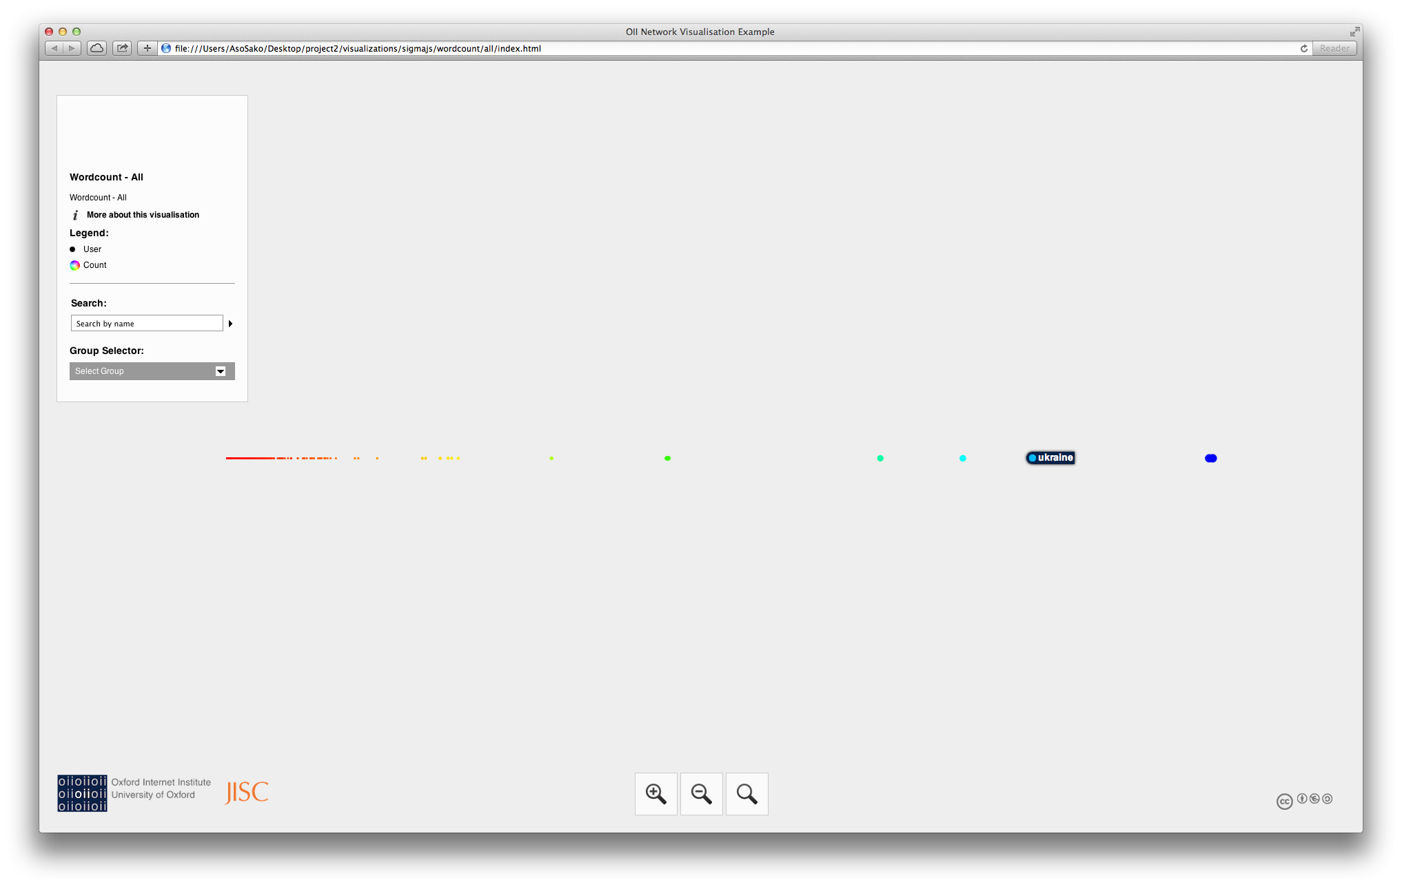**General Look and Feel of Word Count Visualizations:**

**9.2 - Co-Occurrence**

**Top 10 (Counts):**

#russia,#ukraine,11109,0.49203

#crimea,#ukraine,7618,0.27591

#crimea,#russia,4748,0.17197

#putin,#ukraine,2514,0.30995

#crimea,#yalta,2256,0.08171

#ukraine,#yalta,2253,0.2887

#russian,#ukraine,2074,0.44222

#putin,#russia,1903,0.23462

#russia,#us,1547,0.06852

#tymoshenko,#ukraine,1533,0.98206

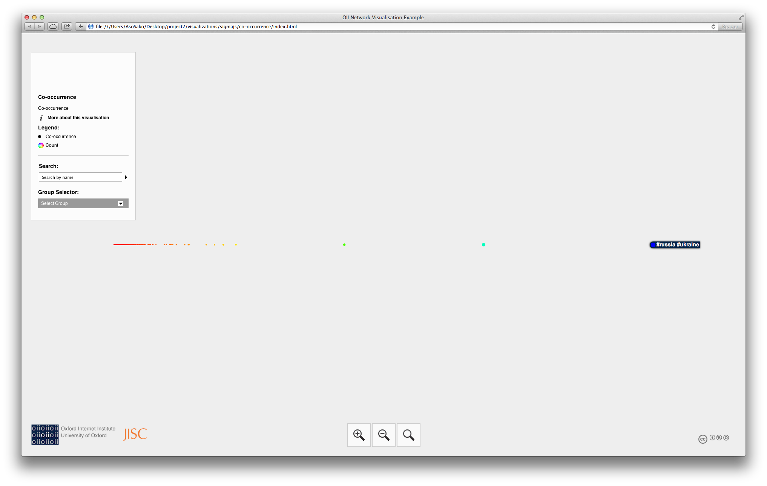**General Look and Feel of Co-Occurrence Visualizations:**

**9.3 - K-Means**

**Top 10 High:**

cnnbrk,HIGH,16205194

nytimes,HIGH,11493325

bbcbreaking,HIGH,9314252

breakingnews,HIGH,6591304

uberfacts,HIGH,6411873

omgfacts,HIGH,6081104

bbcworld,HIGH,6018512

perezhilton,HIGH,5980331

time,HIGH,5614277

peoplemag,HIGH,5471253

**Top 10 Medium:**

wsj,MEDIUM,4269897

whattheffacts,MEDIUM,4187939

reuters,MEDIUM,4154315

huffingtonpost,MEDIUM,4027565

mashable,MEDIUM,3920122

foxnews,MEDIUM,3792041

ap,MEDIUM,3127941

abc,MEDIUM,3103971

newyorker,MEDIUM,3056099

cbsnews,MEDIUM,3029692

**Top 10 Low:**

treadstone71llc,LOW,967004

mstupenengo,LOW,927385

gopro,LOW,913622

gizmodo,LOW,870848

factboook,LOW,858548

statedept,LOW,856510

buzzfeed,LOW,853798

nbcsnl,LOW,853193

marilynmonroedc,LOW,841597

reutersbiz,LOW,841428

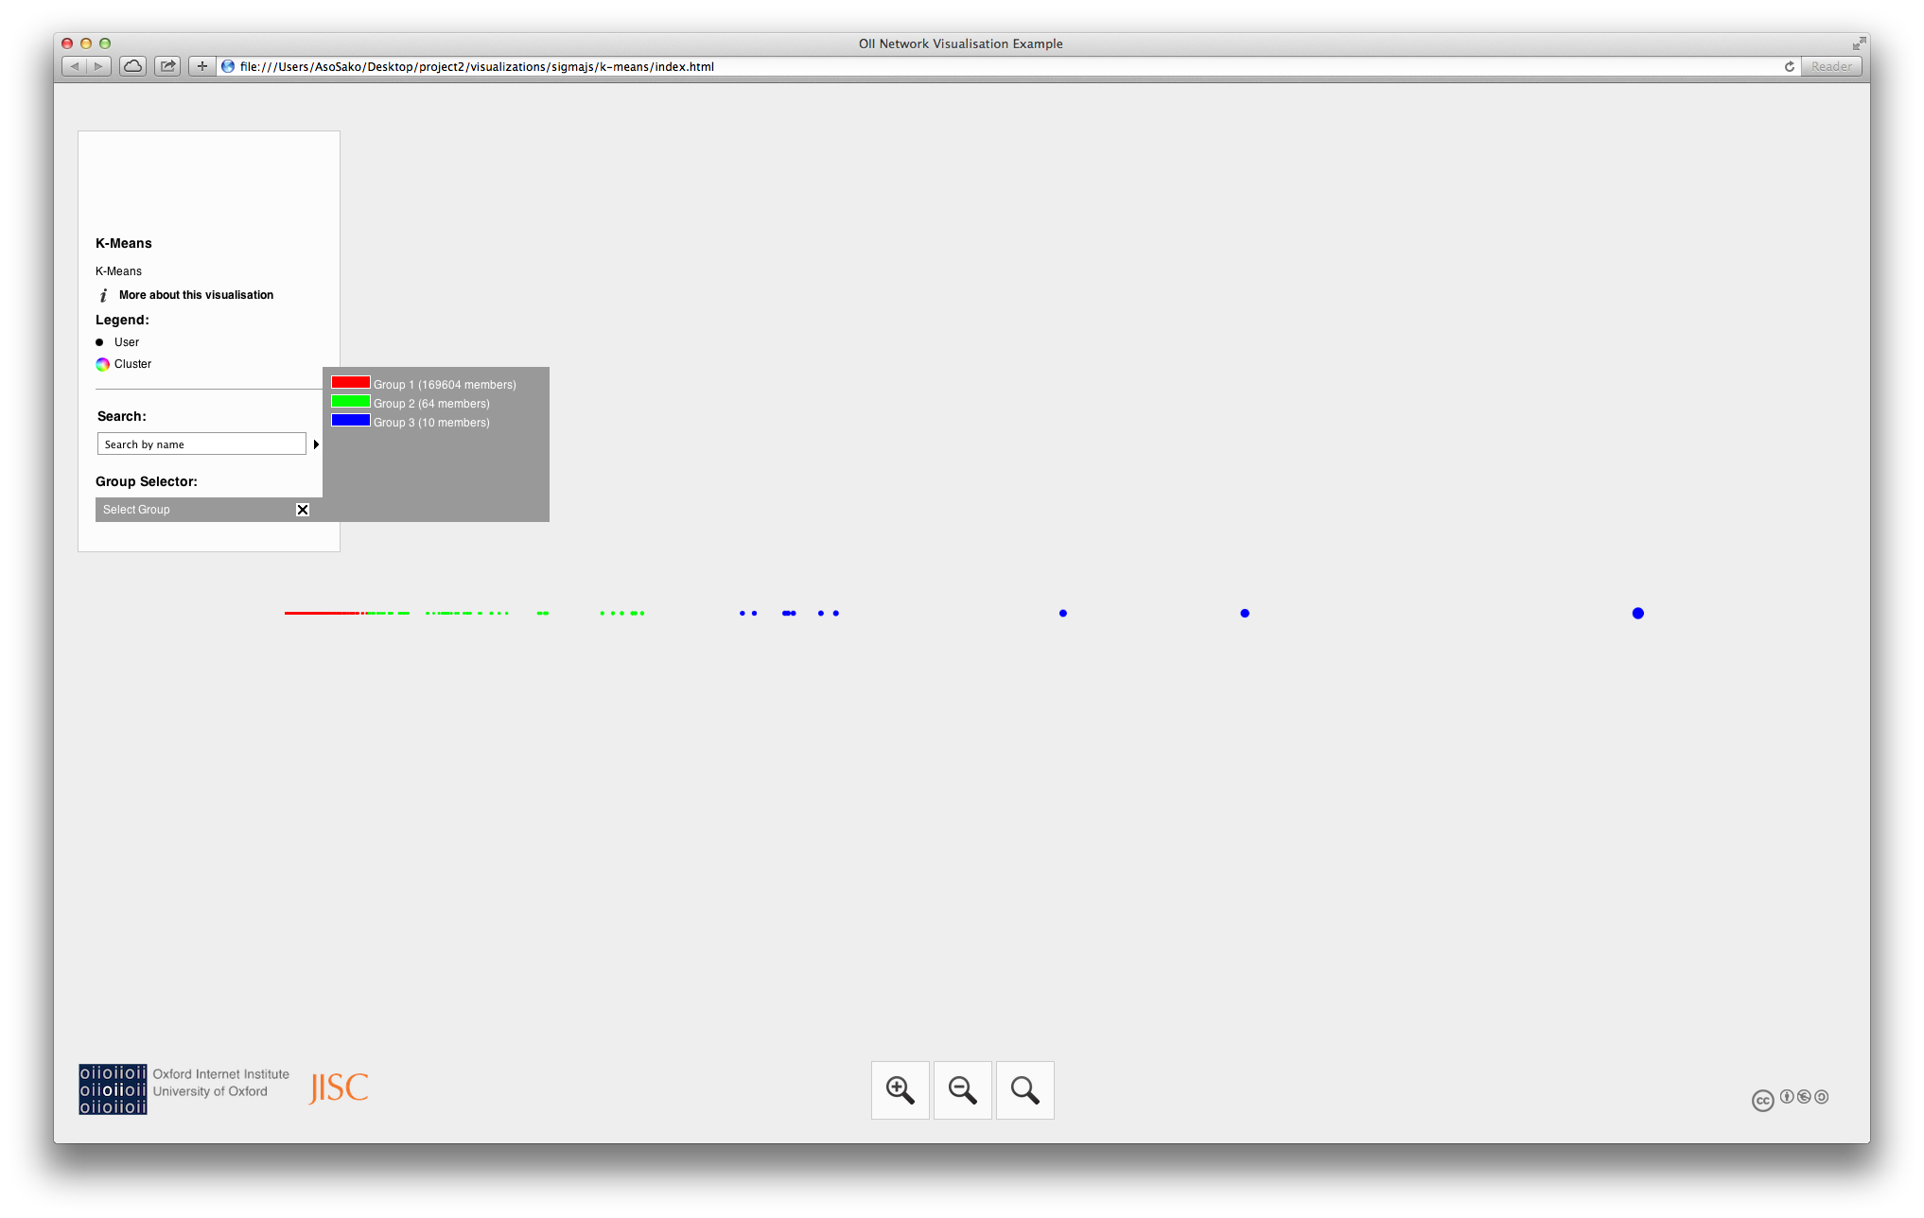**General Look and Feel of K-Means Visualizations:**

**9.4 - Shortest Path (From CNN Breaking News – Top High Group User)**

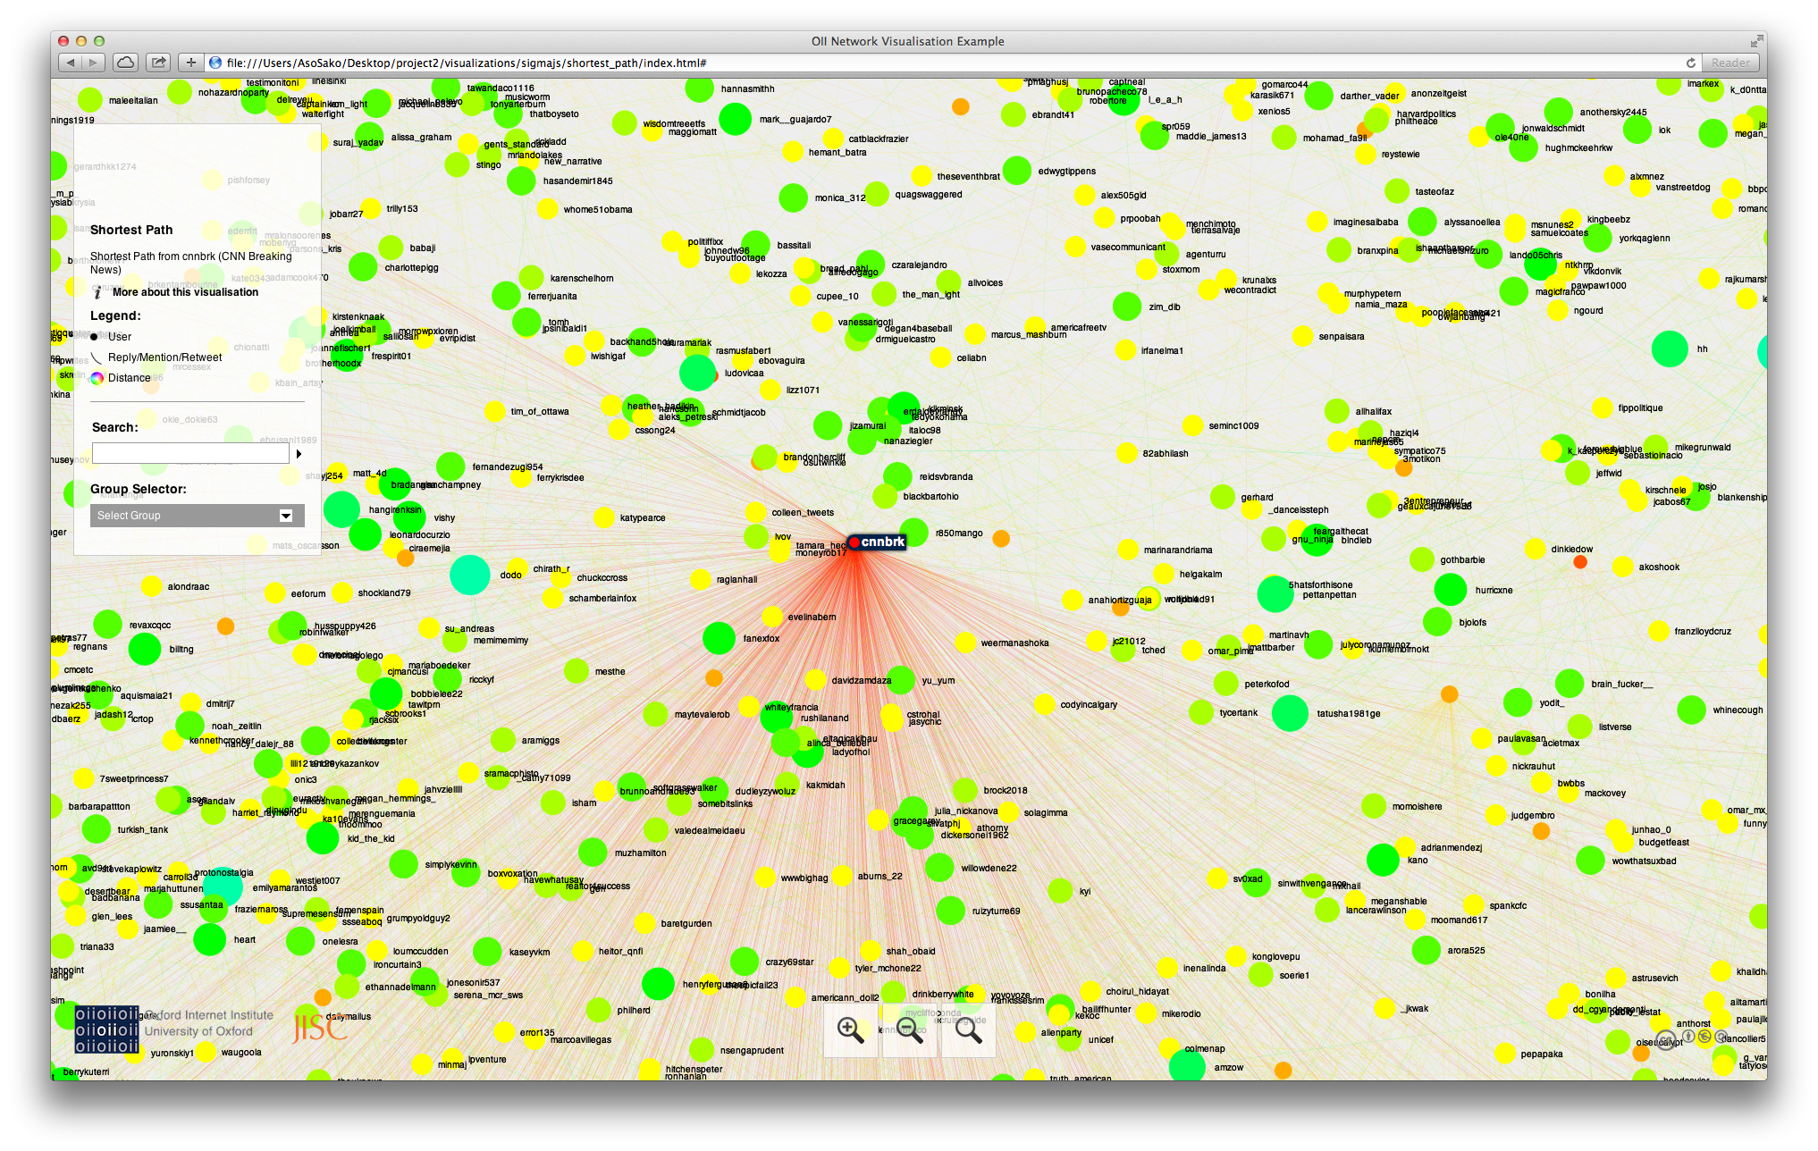

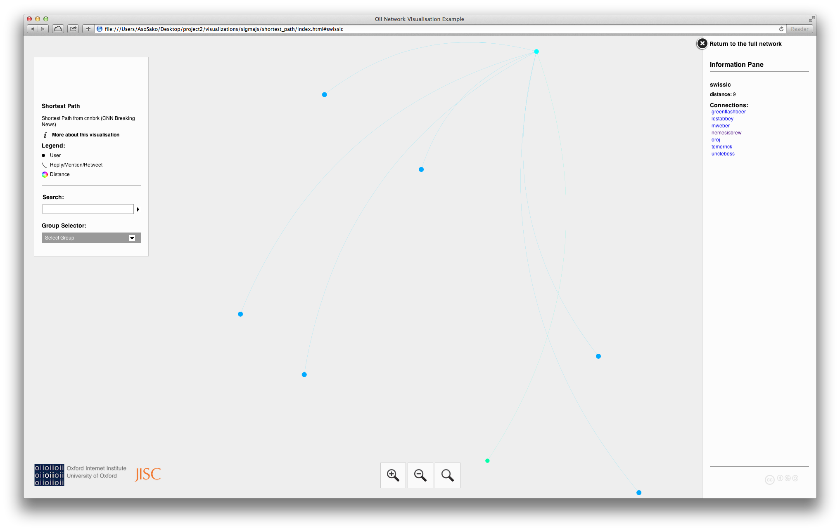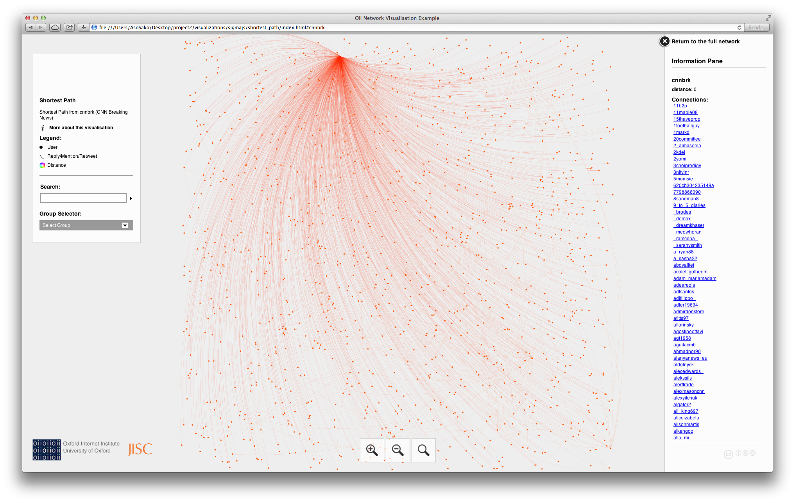**IMPORTANT:** For more please check out /visualizations/sigmajs/ or if you want to use Gephi import the graph files from /visualizations/gdf/

**Readme for Visualizations:**

This readme can also be found in the README.txt in the /visualizations/ directory:

--------------------------------------------------------------------------------

This folder contains the following files:

--------------------------------------------------------------------------------

to_gdf/ - python scripts for converting outputs to Gephi graphs

to_gdf/wordcount.py - transforms wordcount output to gdf

to_gdf/co-occurrence.py - transforms co-occurrence output to gdf

to_gdf/k-means.py - transforms k-means output to gdf

to_gdf/shortest_path.py - transforms shortest path output to gdf

to_gdf/to_gdf.sh - Creates all of the Gephi graph files for this project

gdf/ - Gephi graphs (result of the scripts in to_gdf)

sigmajs/ - Sigmajs Exporter output from Gephi

screenshots/ - select screenshots from the Sigma.js visualizations

--------------------------------------------------------------------------------

To fully utilize the visualizations you need to have the following installed:

--------------------------------------------------------------------------------

Python 2.7.x

Gephi

Sigmajs Exporter

--------------------------------------------------------------------------------

To install the above you need to do the following:

--------------------------------------------------------------------------------

1. Download and install Python 2.7.x from: https://www.python.org/downloads

2. Download and install Gephi from: https://gephi.org/

3. Download Sigmajs Exporter from:

https://marketplace.gephi.org/plugin/sigmajs-exporter/

4. Open Gephi

5. Go to Tools -> Plugins -> Downloaded

6. Click on Add Plugins and add Sigmajs Exporter

7. Click on Install

--------------------------------------------------------------------------------

To run the reproduce the Graph file output in gdf/ using the scripts:

--------------------------------------------------------------------------------

Make sure the directory structure is not changed for this package.

1. Change your directory to: to_gdf/

2. Run: chmod 777 to_gdf.sh

3. Run: ./to_gdf

--------------------------------------------------------------------------------

To import/export graphs from Gephi:

--------------------------------------------------------------------------------

1. Open Gephi

2. Click on File -> Open

3. Select the desired graph file

4. Click OK

5. Go to on File -> Export -> Sigma.js template

6. Click on Browse and select a folder to export to

7. Click OK

--------------------------------------------------------------------------------

IMPORTANT:

--------------------------------------------------------------------------------

It seems Google Chrome has trouble displaying the Sigma.js visualizations

however I have tested it and confirmed it to work in Safari and Firefox.

**10. Extra (Creative)**

Just for fun, for a creative venture, I have extracted coordinates for tweets so that I can plot them using R. I will provide the instructions on them which can be found in the README.txt in the /extra/ folder. I will also provide the plot here, which is in that same directory as well.

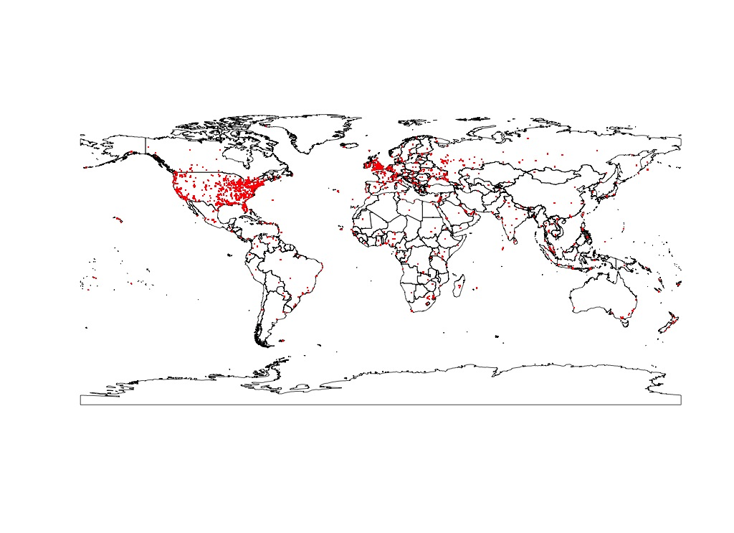

--------------------------------------------------------------------------------

This folder contains the following:

--------------------------------------------------------------------------------

coordinates.csv - coordinates of tweet origin (few provided)

coordinates.r - creates a plot on the world map for the coordinates

coordinates.jpeg - the above mentioned plot

--------------------------------------------------------------------------------

coordinates.csv format:

--------------------------------------------------------------------------------

The coordinates are collected in 'coordinates.csv' in two columns the first with

longitudes and the second with latitudes. This data is intended to be used

separately due to being rarely provided along with the tweet. It is collected

as a creative venture and will not be used during the MR phase of this project.

--------------------------------------------------------------------------------

To run coordinates.r:

--------------------------------------------------------------------------------

1. Install R or R Studio

2. Using R or R Studio run: source('<location_to_file>/coordinates.r')

**11. Lessons Learned**

The Big-Data Content Retrieval, Storage, and Analysis project has taught me many valuable lessons that I am definitely going to take advantage of. First and foremost I learned more about data wrangling, which is an extremely useful skill to have. Using APIs has become a necessity in the sort of big data world we have today. I also got better at Python, which is a good skill to have. More importantly I got one fantastic introduction to Hadoop Map Reduce. I now feel extremely comfortable with the language and methodologies associated with it. In terms of dta analysis I managed to learn some really cool ways to graph large data using Gephi and Sigma.js. Web enabled visualization is truly valuable because it gives one a much better way to browse and understand what is going on.

I would say that this project has been extremely valuable for me. I have found that I can achieve many cool things with ease using Map-Reduce. More importantly I have acquired new ideas for personal projects. It is safe to say that I will definitely dabble with Hadoop again in the future.

The Ukraine Crisis data has been interesting to analyze. The most trending words and hashtags have been fairly predictable. It seems CNN Breaking News is the biggest source of information as it stands. Predictably most users don’t have too many followers.